Task Manager Application – Full Project
Documentation

Project Title: Task Manager (To-Do List Web App)
Technologies: Node.js, Express.js, MongoDB, React

Student Name: Abdulrahman Zuhair masla
Student ID: 445008584
Student Name: Abdullah Ahmed Alsharif
Student ID: 44510274
Student Name: Firas elyas nazzer alam
Student ID: 445010500
Student Name: Sajid alqurashi
Student ID: 445010121
Student Name: waleed ahmed bafaraj
Student ID: 445009309

Table of Contents
2. Table of Contents ................................................................. Error! Bookmark
not defined.

3. Introduction 3
4. System Overview 3
5. Functional Requirements 4
6. Non-Functional Requirements 5
7. System Architecture 5
8. Database Design 6
9. Backend Implementation 6
10. Frontend Implementation 7
11. API Endpoints 7
12. Testing 7
13. Screenshots (Placeholders) 8
14. Conclusion 11
15. References 11

Introduction
The Task Manager Web App is a full-stack application
designed to | help users organize daily tasks. The system
allows user | registration, login, and secure task
management | using a modern MERN-style architecture
(React + | Node.js + MongoDB).

System Overview
The system allows authenticated users to create, edit, update, and delete tasks. Each task includes a title, description, deadline, and status (notcompleted, inprogress, completed).
Below is the Mermaid diagram for the overall system architecture:
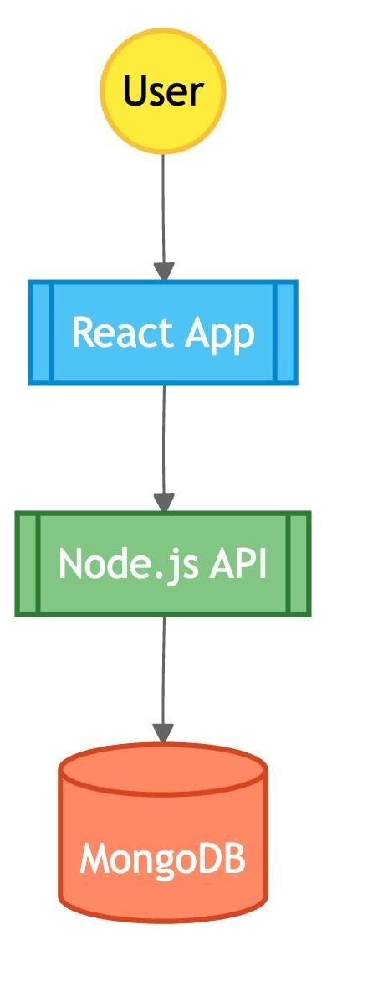

Functional Requirements
- User Registration
- User Login
- JWT Authentication
- Add new task
- View all tasks
- Update task
- Change task status
- Delete task
- Each user only sees their own tasks

Non-Functional Requirements
- Usability: Clean and simple UI
- Security: Password hashing, JWT authentication • Performance: Fast CRUD operations
- Reliability: Database must store tasks persistently
- Scalability: Backend supports multiple users

System Architecture
The architecture follows a client-server model.
Below is the Mermaid diagram:
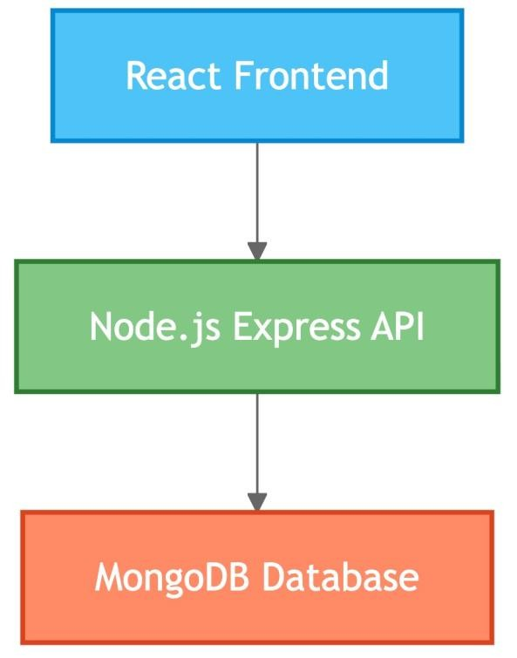

Database Design
The system uses MongoDB with two collections: Users and Tasks.
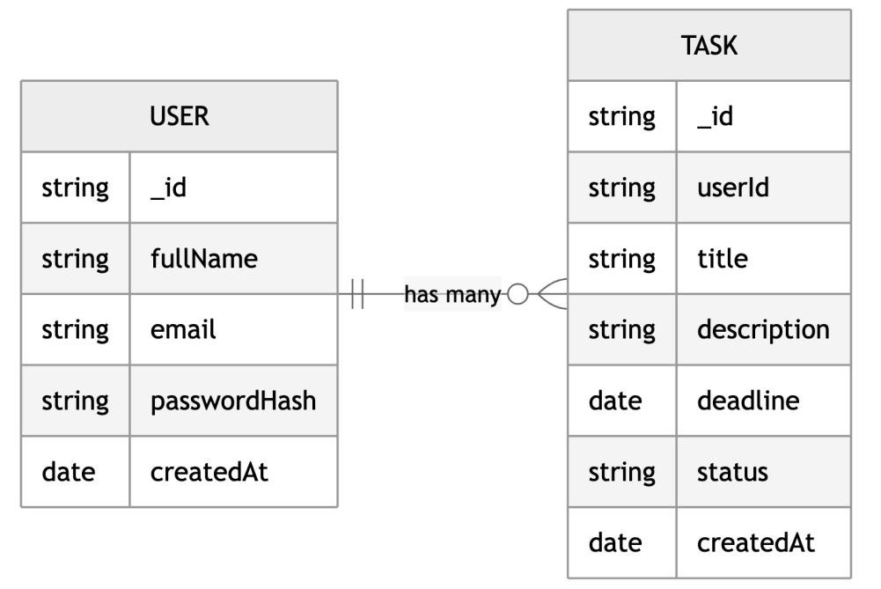

Backend Implementation
Backend is implemented using Node.js, Express.js, and Mongoose. It follows MVC structure:
/backend
/config/db.js
/models/User.js
/models/Task.js
/routes/authRoutes.js
/routes/taskRoutes.js
/controllers/authController.js
/controllers/taskController.js
/middleware/authMiddleware.js

Frontend Implementation
Frontend is implemented in React with the following structure:
/frontend
/src
/pages (Login, Register, Dashboard)
/components (TaskForm, TaskTable, NavBar)

/utils/api.js

API Endpoints
AUTHENTICATION
POST /api/auth/register
POST /api/auth/login
TASKS (Protected with JWT)
GET /api/tasks
POST /api/tasks
GET /api/tasks/:id
PUT /api/tasks/:id
DELETE /api/tasks/:id

Testing
- Tested registration with valid/invalid emails
- Tested login with correct/incorrect passwords
- Verified Protected Routes require JWT
- Verified CRUD operations for tasks
- Verified database stores new tasks correctly

Screenshots (Placeholders)
1. Login Page
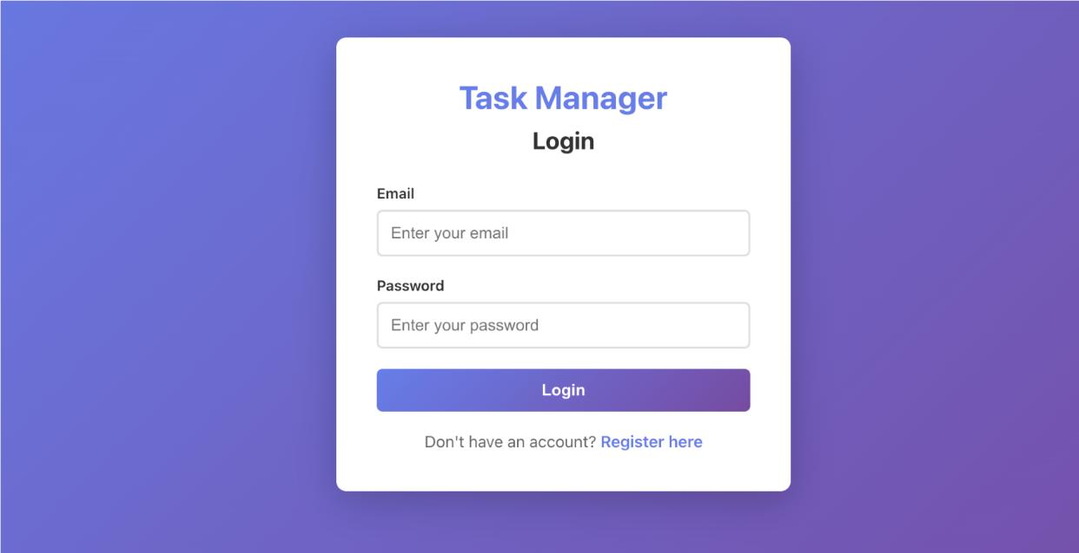

Register Page
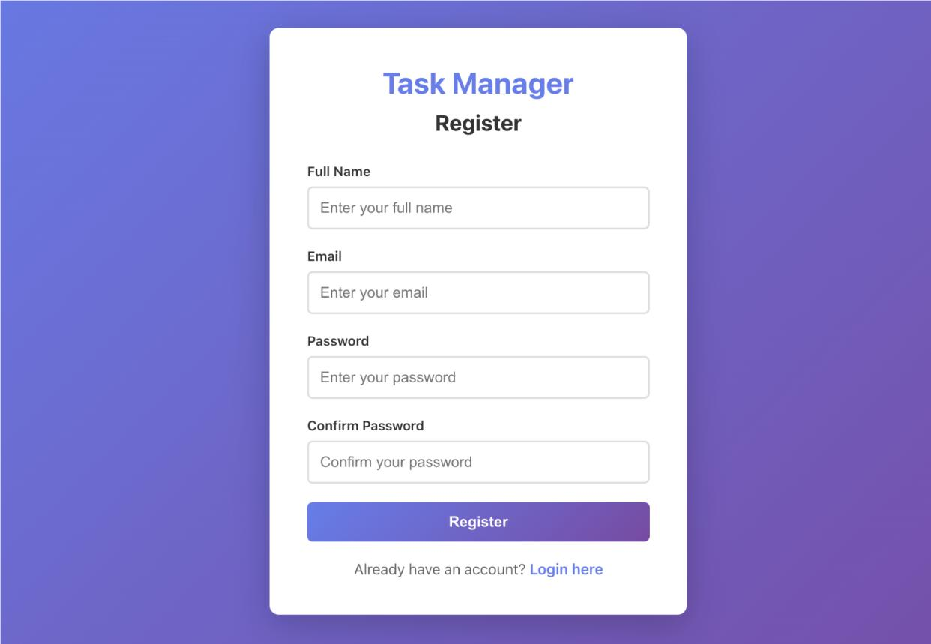

Dashboard Page
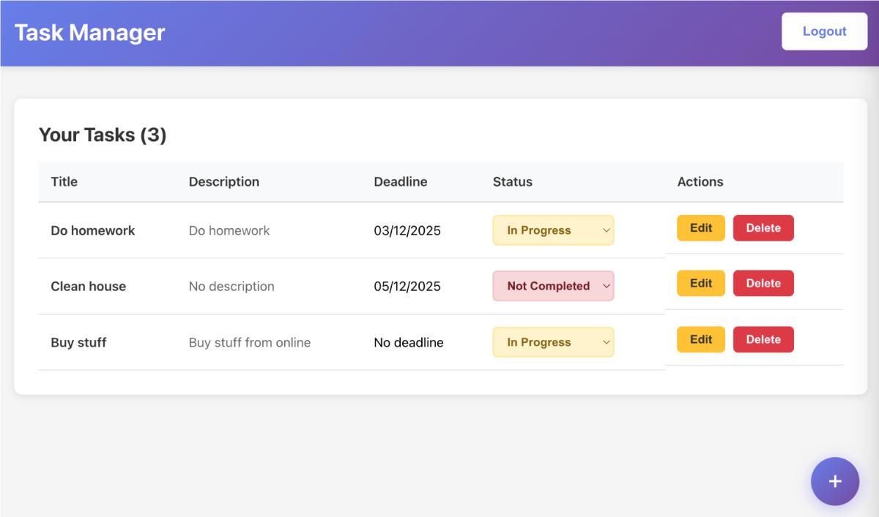

Add Task Form
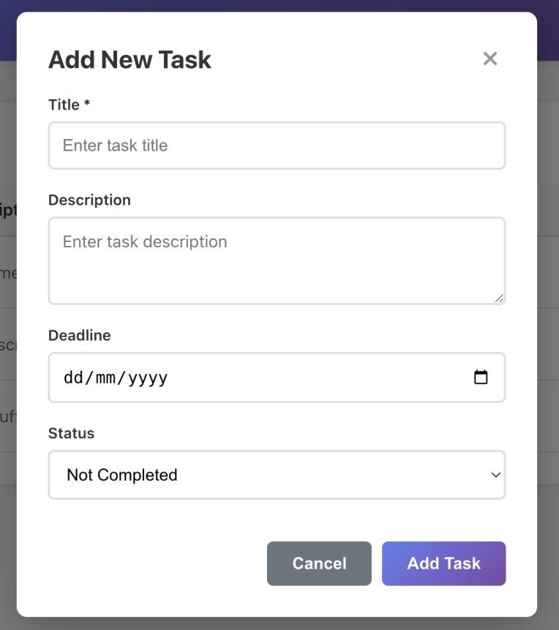

Edit Task Form
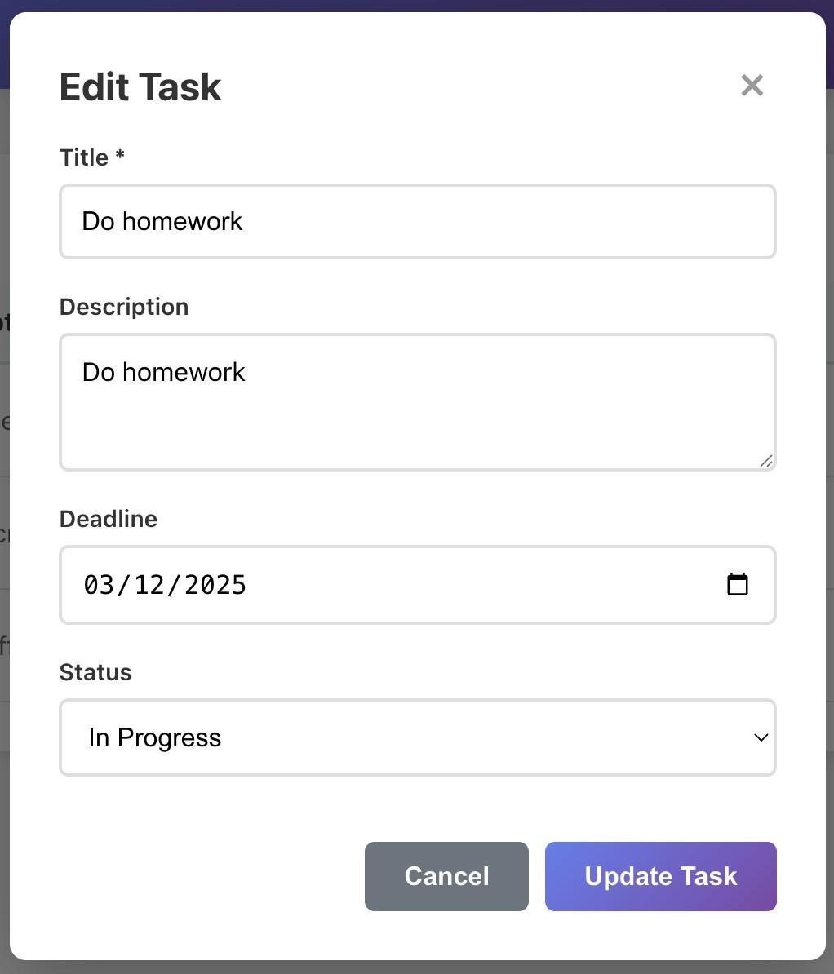

Conclusion
This project successfully demonstrates a full-stack MERN-style application with authentication, task management features, database persistence, and modern web development practices.

References
- Node.js Documentation
- Express.js Documentation
- MongoDB Documentation
- React Documentation
- JWT Official Docs

